Island Lake Service Report
Site ___________________Island Lake________________ Date/Time______07/14/22_____

Service Description ____________Algae Treatment__________________________

Onsite Personnel ___________Environmental Aquatic Management_____________________

Site | Product | Amount | Target Plant | DO (MG/L) | Temp | PH | Secchi | Boat/Shore
Eastway Bay
Forest Bay | Clipper | 1ppm | Duckweed
Circle Lagoon
Little Island
Channel
Other

Comments:
Duckweed treated in Forest Bay. Due to low oxygen levels (under 5 ppm) in rest of lake, unable to treat. Do not want to risk a fish kill. No restrictions on water.

Report By _______Kevin Dahm____________________ Date__________07/14/22_______

Mark location of treatments on the map below:
Channel
Eastway Bay

Circle Bay
Eastway Bay

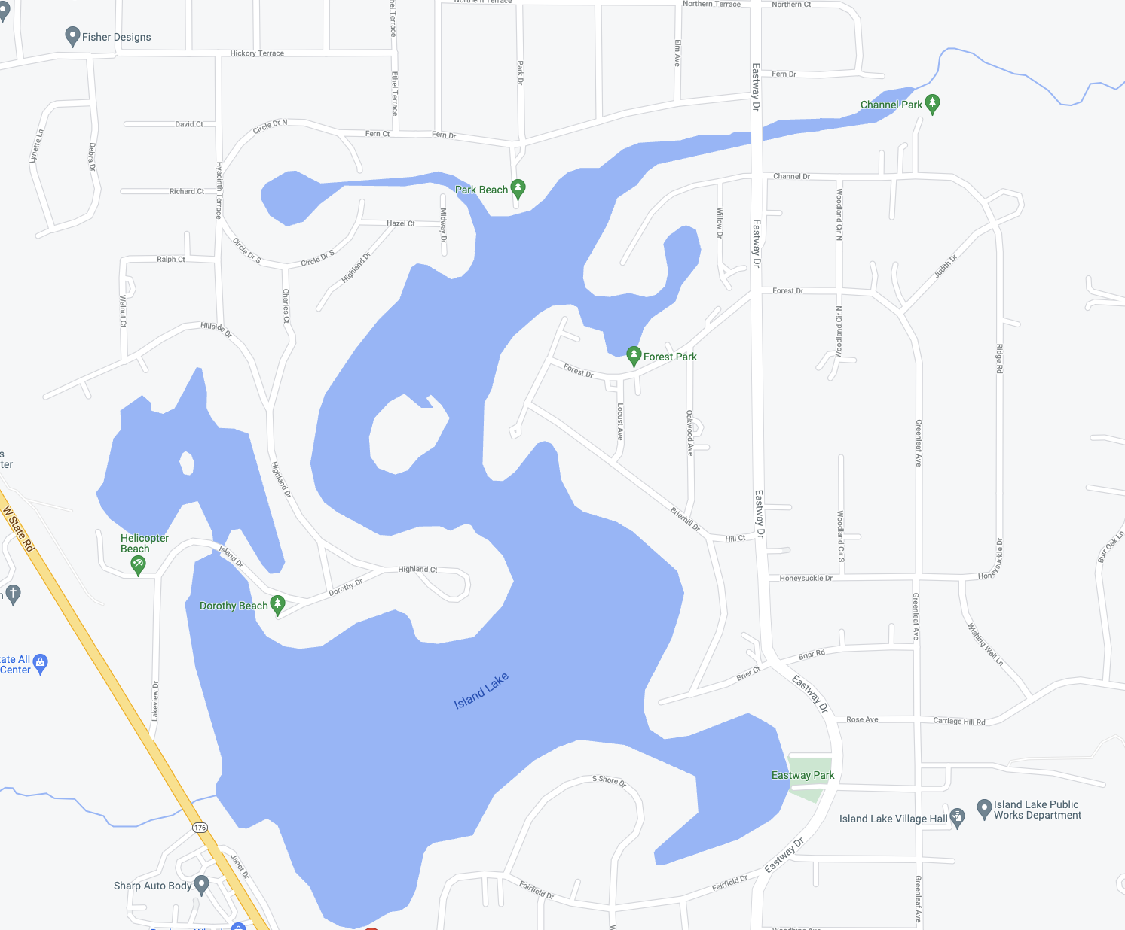
Forrest Bay
Little Island Bay
East Way Bay
Eastway Bay

PHOTOS:

Forest Bay:

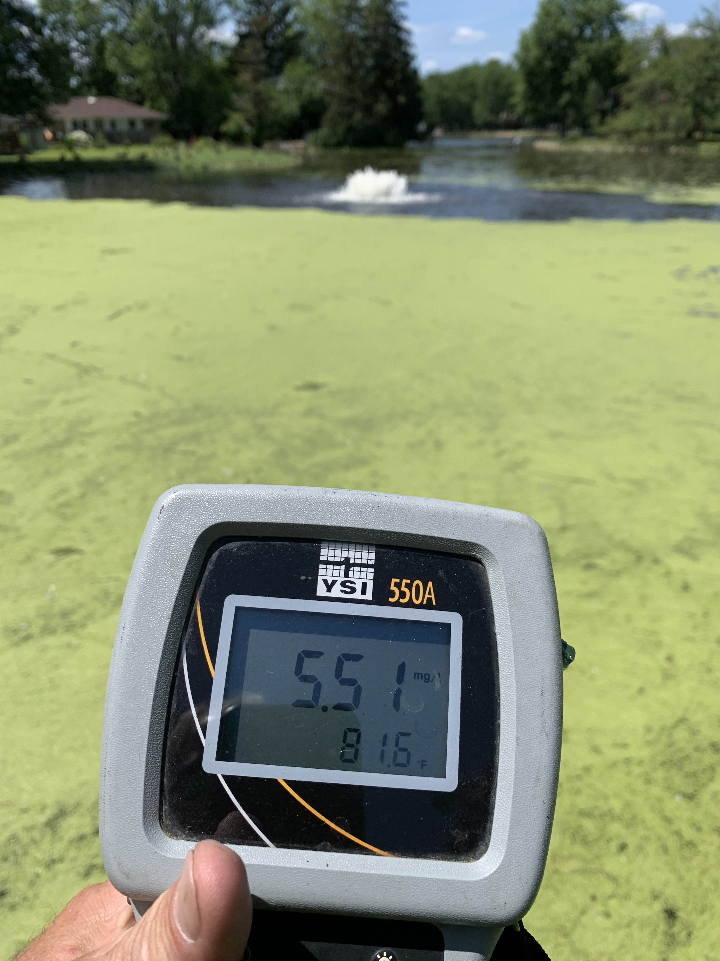

Lake:

